I am letting go. Letting go of what I wanted this season to be. Letting go of my priors. We are a quarter of the way through the season, and while that's still a small sample size, let's be honest – 17 games is also a small sample size.
via GIPHY
Here's what we know:
The Macro
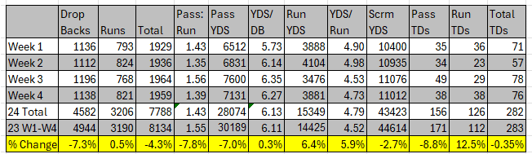
Compared to the first four weeks of the 2023 season, total plays from scrimmage are down 4.3%. Dropbacks are down 7.3%, while running plays are up .5%.
The total number of TDs has rebounded to just one off the 2023 pace, but we're -15 in passing TDs and +14 in rushing TDs.
You expect more efficiency with fewer plays, and we're seeing that. Yards per dropback is up slightly, and yards per run are up 6.4%!
Here's the thing: With TD scoring having rebounded to last year's pace, one could argue that, although defenses want offenses to put together long drives (taking away big plays and creating more opportunities for penalties and turnovers), the long drives are working. So, teams will likely remain incentivized to run if running efficiency is up and long drives aren't stalling (like in weeks 1 and 2).
We nerds can argue about efficiency and playing into the defenses hands all we want, but I'm starting to think we're the guy in the middle of the mid-curve meme, flanked on both sides with a dufus and a Jedi telling me to "take what the defense gives you" and "run the damn ball."
Thus, what I feared in Chapter 1 and hypothesized about in Chapter 2, I am now simply accepting in Chapter 3. The run has been established.
What does that mean, from a practical standpoint, for fantasy purposes? After all, if you take a cursory look at FPPG, you'll see that after RB21, starting WRs in your flex spots makes more sense. Not coincidentally, 21 RBs have scored more than 1 TD on the ground this season.
The top 20 RBs don't grow on trees, and WRs are far more plentiful. So, how do we cash in on the increasing number of rushing TDs we've seen and expect to see moving forward?
The Micro
Given the data we have, we can do our best to predict which RBs could make their way into that top 20 in the coming weeks. After all, we know darn well that some of these top 20 RBs are being propped up by TDs (which are difficult to predict) and volume (which is easier to predict than TDs but can also be impacted by game-script).
What we're looking for, though, is opportunity. Aside from injury, how do we predict which RBs will be given more opportunities? The best way I can conceive is by success rate. If an RB has been successful with the opportunity they've gotten, their coaches will be incentivized to give them more opportunities.
Thus, I looked at success rates for running backs with at least 25 carries this season to see if we can predict which RBs should or could be getting more opportunities. The idea is simple: Let's target these guys in trades before the cat is out of the bag. The following numbers are according to Fantasy Points Data Suite.
Incidentally, there are 50 RBs with at least 25 carries this season (I wanted a decent sample). Of those 50, 13 have posted success rates of 50% or better in both Zone Concepts and Man/Gap Concepts.
I've highlighted them below in green, along with their success rates in each category, FPPG, and Expected FPPG.
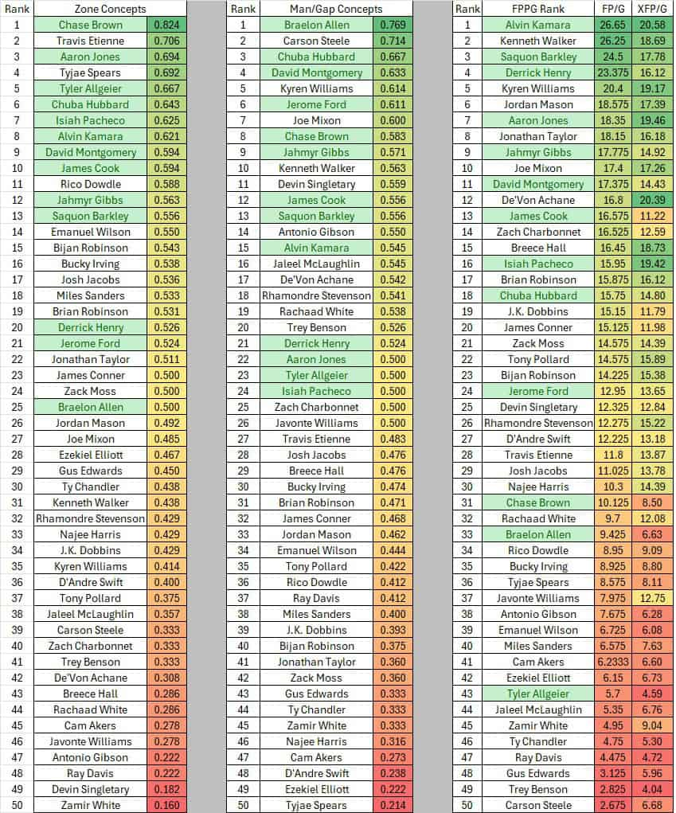
Not surprisingly, 10 of the 13 I mentioned are in the top 24 in FPPG. The three that are not are Chase Brown (31), Braelon Allen (33), and Tyler Allgeier (43). The other two that might surprise you are Chuba Hubbard (18) and Jerome Ford (24).
Now, Jerome Ford and Chuba Hubbard are good players with similar problems. They have teammates who are probably better than them (Nick Chubb and Jonathon Brooks) returning from injury soon.
Braelon Allen and Tyler Allgeier also have a problem in common. They're behind two of the best running backs in the NFL (Breece Hall and Bijan Robinson). Though their success rates in both categories are better than their superstar counterparts, let's be honest; defenses play a bit differently when Breece and Bijan are on the field (their coaching and play-calling don't seem to be doing them any favors either),
Then there's Chase Brown. Sure, he has a Zack Moss problem, but data doesn't support the notion that Moss is better than him. He's outperforming him in both categories and provides a lot more juice.
It seems evident to me that the player who is likely to overtake his backfield counterpart in this group is Brown. In Week 4, they were at an even carry split for the first time. This is not to disparage Moss, a fine player, but the coaches seem to be taking notice, and Brown's takeover appears imminent. In simpler terms – TRADE FOR CHASE BROWN!
Ford and Hubbard are solid depth options, likely available cheaply, with their teammates returning soon. Allen and Allgeier also have upside, with Allen being a flex option even alongside a healthy Breece in deeper leagues.
I'm exploring all of these players because I believe they can deliver top-20 RB production if given the chance.
Now, let's analyze these committees to spot where more opportunities might emerge based on their success rates so far.
Bucky Irving vs. Rachaad White: they're comparable in man/gap schemes with a slight edge to White. Bucky is far superior in the zone, with less than half the attempts in those concepts. White's experience, passing game understanding, and concerns about Bucky's size will keep this split near even. Probably making both flex plays and not reliable RB2s.
Tony Pollard vs. Tyjae Spears: Tyjae has been among the best in the league in zone concepts but is dead last in man/gap of our sample of 50. Pollard has been adequate at both. Both players offer similar passing game skills. I'd expect this split to continue to favor Pollard.
Jaleel McLaughlin vs. Javonte Williams: This one is somewhat interesting. McLaughlin has a better success rate than Javonte Williams in zone and man/gap concepts. He's also definitively the better pass catcher of the two. He's 187 pounds, so I don't expect him to get the lion's share of the work. Instead, I hope the Broncos are anxiously awaiting Audric Estime's return. Javonte looked as good as he has all season in week 4, so perhaps something clicked, but if that was a flash in the pan, I imagine he may be a trade candidate when Estime comes off IR.
James Cook vs. Ray Davis: Going into the season, I was a James Cook skeptic. Through four weeks, he's in the top 12 in success rate in both categories and the RB 13 in FPPG. Ray Davis has struggled in his limited zone runs (9) and is also in the bottom third in man/gap. I still have faith in Davis, but Cook has a stranglehold on lead-back duties in Buffalo.
Rhamondre Stevenson vs. Antonio Gibson: Both Gibson and Stevenson have excelled in man/gap concepts at over 50% success, each with a slight edge over Gibson. "Mondre" has a definitive edge in zone schemes. There's been talk of a Gibson takeover due to Stevenson's fumbling issues, but Gibson was no stranger to fumbling during his time in Washington. I expect the split to remain similar, barring another fumble by Stevenson. As such, he should stay in RB2/flex land, and Gibson remains a low-end flex with a contingent upside.
Emmanuel Wilson: No dichotomy here; Josh Jacobs' role is secure. Just a note – Emmanuel Wilson looks good. Per the numbers, he's been passable in man/gap concepts (44% success) and flat-out impressive in zone concepts (55%). As I said, Jacobs' job is safe, but I don't expect a cakewalk to be relevant for Marshawn Lloyd when he comes off IR. Wilson is earning his keep.
James Conner vs. Trey Benson: This is interesting because the Cardinals have been running many more man/gap concepts than zone. Conner has a 50% success rate on the zone concepts, whereas Benson has 33% (on only six attempts). However, Benson has the edge on the map/gap. There’s more behind the decision to focus on Conner, but I expect Benson's role to grow as he adjusts. It might be worth checking his availability. Conner is ranked #20 in PPG, and if anything happens to him, Benson could match that success with more big-play potential. This was always the hope for Benson, but now we have data backing his skills in man/gap schemes.
We'll revisit running backs soon. As stated at the top, the run has been established. Accept it and capitalize on it.

